
2018 Donate Life Rose Parade® Float
Making a Difference National Rose Dedication Program
Brought to you by Dignity Memorial

Program Talking Points
- Thanks to our generous partnership with Dignity Memorial, every OPO, Transplant Center, Eye Bank and Tissue Bank in the U.S. will be presented with a silk rose recognizing their efforts in making a difference in the community of organ, eye and tissue transplantation.
- Each Making a Difference Rose provides a national opportunity to share a meaningful and powerful message of hope and inspiration as we come together and share our mission to save and heal lives.
- Donate Life State Team Leaders across the country will be presenting Making a Difference Roses to their partners as a national symbolic effort for their support and efforts to save lives through organ, eye and tissue donation.
- Each OPO, Transplant Center, Eye Bank and Tissue Bank across the country will be represented on December 29th with a dedicated Making a Difference Rose placed on the 2018 Donate Life Rose Parade Float, The Gift of Time.
  - The roses will be placed next to the Donate Life and Done Vida logos.

Implementation and Media Efforts
- This program has been created to personally thank and acknowledge the efforts of your local OPO’s, Eye Banks, Tissue Banks and Transplant Centers for their efforts to save lives through organ, eye and tissue donation.
- The presentation of the Making a Difference Rose can be given in various ways to acknowledge, enhance and build current partnerships:

  - Individual Dedication Opportunities:
    - Set an appointment to visit your local OPO, Eye Bank, Tissue Bank and Transplant Center to present the Making a Difference Rose.
      - Present the silk rose to key staff in the office
      - Present a framed Making a Difference National Rose Dedication Certificate
      - Take an individual or group photo presenting the rose and certificate
        - Email your photos to Khostert@onelegacy.org by December 15th
        - Photos will be used to create a photo collage of efforts across the country
      - Invite someone personally affected by organ, eye or tissue donation to share their story
      - Invite local media to cover your presentation if approved by your partner.
      - Provide Donate Life Rose Parade Float Pass It On cards
      - Invite the staff to watch the parade on New Year’s Day as their dedicated rose is featured on the Donate Life Rose Parade Float
        - All roses will be placed in the pink section located next to the Donate Life Logo
  - Group Dedications Opportunities:
    - Transplant Centers, Eye Banks, Tissue Banks Making A Difference
      - Create an event to invite and present Making a Difference Rose and framed certificate to each Transplant Center, Eye Bank or Tissue bank
      - Share best practices of community outreach
      - Invite Transplant Recipient to share their story
      - Invite media to cover event

      - Share statistics in your local area

OneLegacy Transplant Centers Making a Difference Event OneLegacy General Staff Meeting – OPO Employees


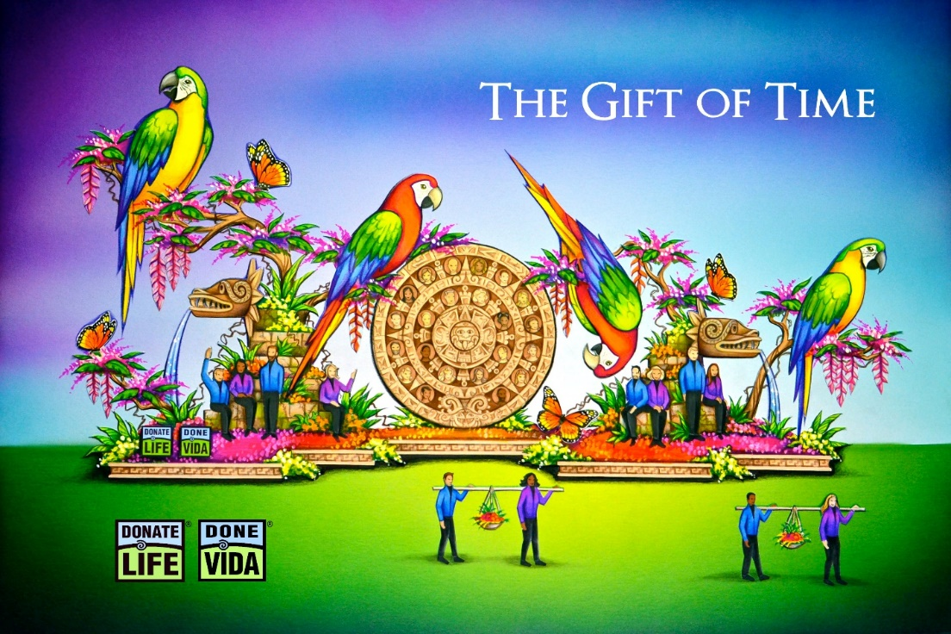

Celebrating its 15th year, The Donate Life Rose Parade® float continues its mission to save and heal lives by sharing the gift of life and delivering the message of organ, eye and tissue donation to the world. Families of deceased donors are honored to see their loved ones’ floral images highlighted as part of the float. Living donors and recipients bring the float to life by riding or walking beside the float. This year’s parade theme, Making a Difference, celebrates the power of kindness and the people in our communities that are selflessly making a positive difference in our lives. The Gift of Time is truly the greatest gift any of us can bequeath to a waiting recipient, showcasing the power that each of us has to help one another.
The 2018 Donate Life Rose Parade® float, The Gift of Time, depicts a vibrantly colored, tropical backdrop that dates back to the ancient civilizations of Mexico, celebrating the gift of life as 16 costumed riders sit alongside the jungle, against stone carvings, drawing on the strength they have gained from their donors to continue and thrive on life’s journey. The monumental Aztec calendar draws the eye to the center of the float, where 44 donors are honored with floragraphs. This ancient calendar reminds us of the enduring, life-saving power of the generosity of donors and families. Alongside the float, eight living donors and recipients carry baskets of fruit and flowers in celebration of the renewed life they have shared with one another and the world. The beauty, richness, and potential of life is represented by the vivid flock of macaws perched over the lush floral canopies, ready to take flight.
As the world's most visible campaign to inspire organ, eye and tissue donation, the Donate Life Rose Parade® float inspires viewers to save and heal more than one million people in need of organ, eye and tissue transplants each year.

