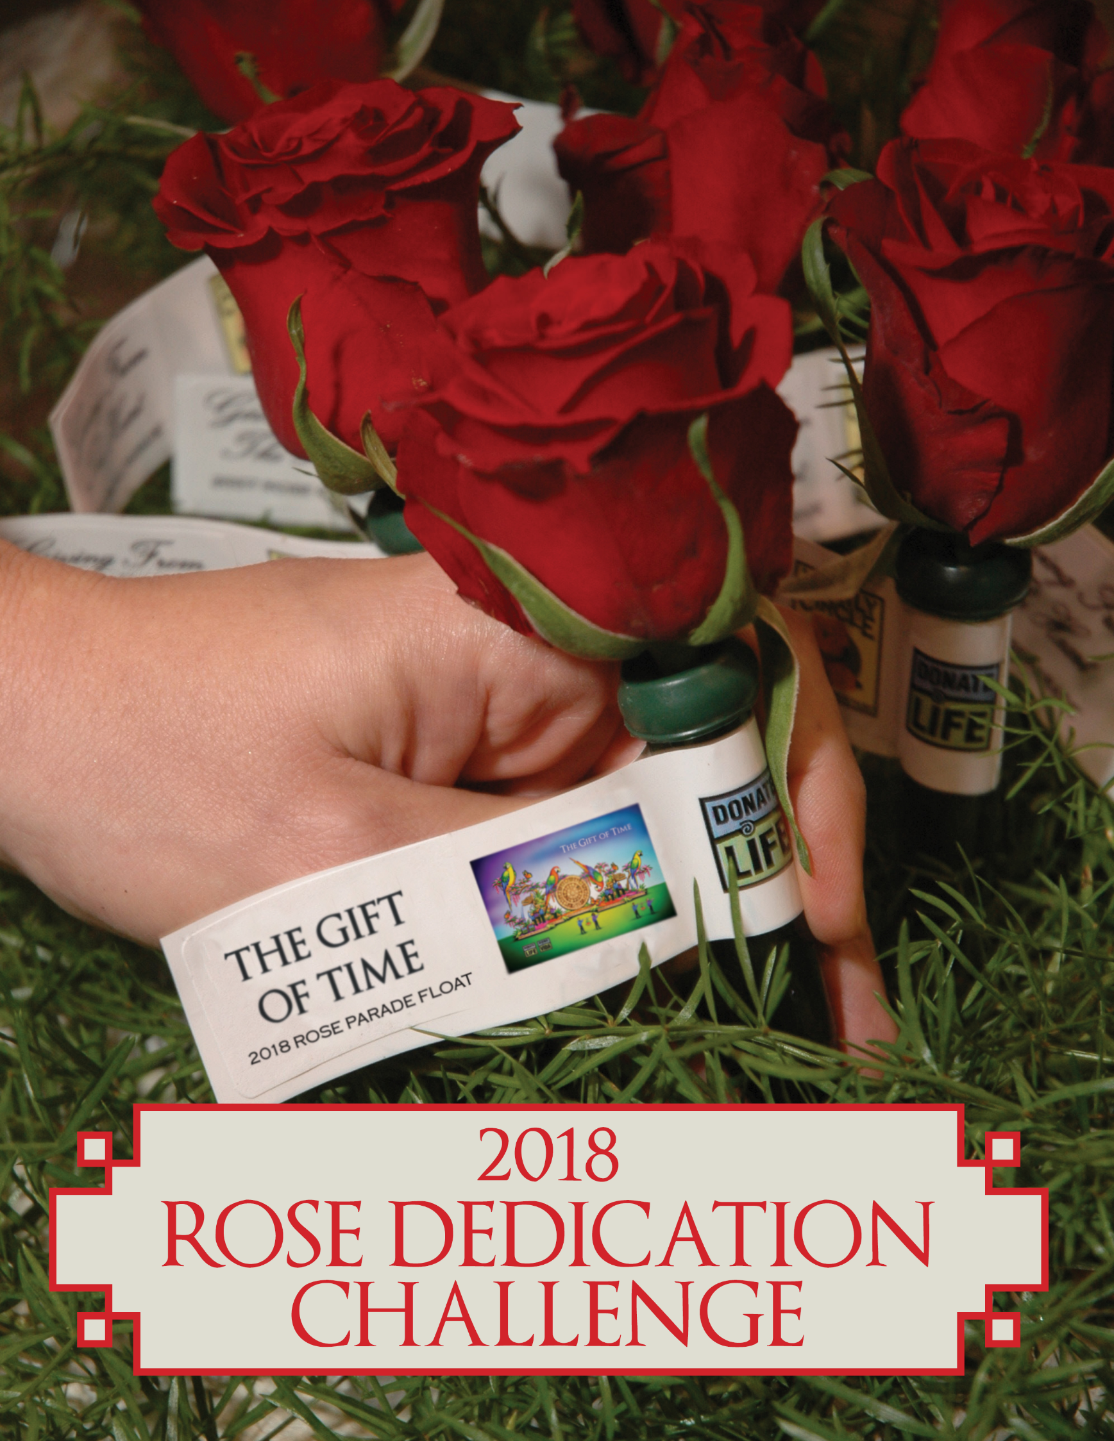


2018 Donate Life Rose Parade® Float
Making a Difference National Rose Dedication Program
Brought to you by Dignity Memorial

Donate Life State Team Leaders,
As we celebrate the 15th Annual Donate Life Rose Parade Float, The Gift of Time, we are honored to unveil a new national program thanks to our partnership with Dignity Memorial to engage and give thanks to all OPO’s, Transplant Centers, Eye Banks and Tissue Banks across the country. The Making a Difference National Rose Dedication Program, Brought to you by Dignity Memorial, will provide an national opportunity to share a meaningful and powerful message of hope and inspiration as we come together and share our mission to save and heal lives. And we need your help!

What is the Making a Difference Rose Dedication Program?
- Thanks to our partnership with Dignity Memorial, every OPO, Transplant Center, Eye Bank and Tissue Bank in the U.S. will be presented with a silk rose to honor all those who have given the gift of life, received the gift of life or are waiting to receive the gift of life across the nation.
- This program will provide opportunities to engage your State Team's members, volunteers, community and media in support of the Donate Life mission through a national symbolic effort.
- Honorary Making a Difference roses will be placed on the 2018 Donate Life Rose Parade Float on December 29th at 5pm by Dignity Memorial, The President of AATB, the Program Manager of NATCO and the Board Chair of DLA generating additional media opportunities.
How can Donate Life State Team Leaders Help?
- Donate Life State Team Leaders are ask to lead the distribution efforts in your state.
- State Team Leaders will be provided a toolkit at the State Team Leader Workshop in Richmond, VA on October 23rd.
- Toolkits will include a silk rose in a vial with a dedication tag attached for each OPO, transplant center, eye bank and tissue bank on your state team. Personal dedications can be placed on the back of each tag customized for your member organizations.
  - **Note: Rose Dedications should not be returned.
- Toolkits will also include:
  - Talking points regarding the Donate Life Rose Parade Float and the Making a Difference Rose Dedication Program
  - Ideas to create events and generate media opportunities surrounding the rose presentations
  - Templates for certificates, posters and signage to be used at your events and presentations can be found at http://www.donatelifefloat.org/wp/media-kit/ under the Making a Difference Rose program
- Donate Life State Teams will have the opportunity to present Making a Difference roses to your OPOs, transplant centers, eye banks and tissue banks to say thank you for their support in making a difference and solicit media as well as social media exposure.
- We encourage you to take pictures of your Making A Difference presentations/ceremonies to Kathleen Hostert by December 15th to create a collage of your efforts across the country.

Please direct any questions to Kathleen Hostert at 714-264-5030 or email khostert@onelegacy.org with any questions and we appreciate your support of this program!


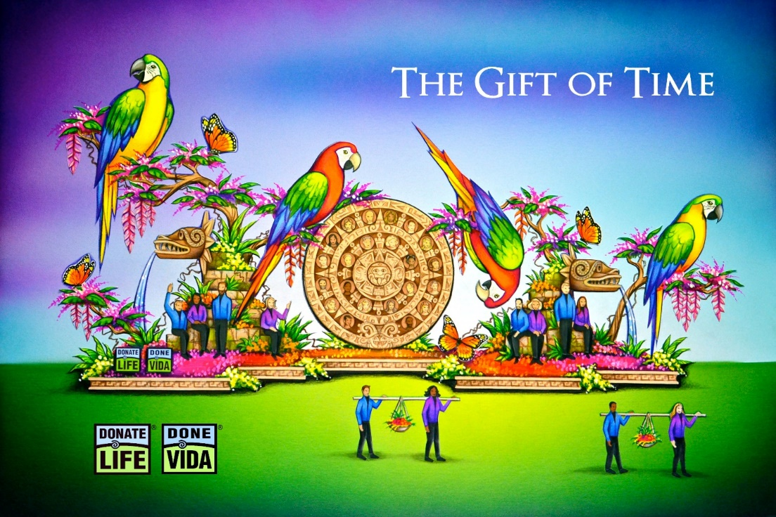

Celebrating its 15th year, The Donate Life Rose Parade® float continues its mission to save and heal lives by sharing the gift of life and delivering the message of organ, eye and tissue donation to the world. Families of deceased donors are honored to see their loved ones’ floral images highlighted as part of the float. Living donors and recipients bring the float to life by riding or walking beside the float. This year’s parade theme, Making a Difference, celebrates the power of kindness and the people in our communities that are selflessly making a positive difference in our lives. The Gift of Time is truly the greatest gift any of us can bequeath to a waiting recipient, showcasing the power that each of us has to help one another.
The 2018 Donate Life Rose Parade® float, The Gift of Time, depicts a vibrantly colored, tropical backdrop that dates back to the ancient civilizations of Mexico, celebrating the gift of life as 16 costumed riders sit alongside the jungle, against stone carvings, drawing on the strength they have gained from their donors to continue and thrive on life’s journey. The monumental Aztec calendar draws the eye to the center of the float, where 44 donors are honored with floragraphs. This ancient calendar reminds us of the enduring, life-saving power of the generosity of donors and families. Alongside the float, eight living donors and recipients carry baskets of fruit and flowers in celebration of the renewed life they have shared with one another and the world. The beauty, richness, and potential of life is represented by the vivid flock of macaws perched over the lush floral canopies, ready to take flight.
As the world's most visible campaign to inspire organ, eye and tissue donation, the Donate Life Rose Parade® float inspires viewers to save and heal more than one million people in need of organ, eye and tissue transplants each year.

